For this mockup i initially struggled on what tv show or movie to base my mockup on. I looked back on what sources of media I've consumed over the course of break. I knew i did not want to do a Metroidvania game because i found the Ui and game play too boring for a Pixel art mockup as the genre was vastly oversaturated in the 90s. I also thought that the tv shows I've seen did not fit the genre. I then thought about the anime I've seen and i really enjoyed binge watching delicious in dungeon. I really liked the fantasy genre on anime and i found that it fit the narrative of the original Final fantasy games. in the show the cast fight and eat monsters within a dungeon after a character was eaten by a dragon. I was searching online for any underground dungeon that match the type of creature the One of the delicious in dungeon cast fights. I stumble upon a final fantasy combat that matched a notable fight in the show is against is a water sprite called an Undine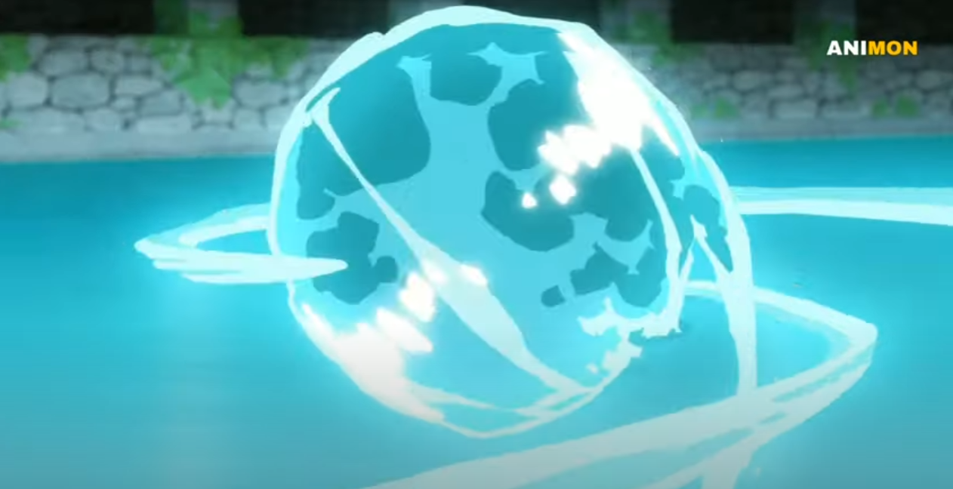It fit so well because the game characters fight a kraken on water while in the show the characters previously fought creatures on water while using a water walking spell before fighting this boss Monter that nearly wipes them. I wanted to include the cast as final fantasy characters but i struggled with making it work that i had to ultimately scrape the idea. Remnants of the idea are in the mockup I wanted to include Laios the fighter, Marcille the mage, and Senshi the dwarf barbarian.